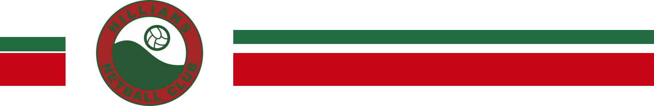

UNIFORM & MERCHANDISE ORDER FORM

Players Name ____________________________________________ Parent/Guardian Name _______________________________

Phone Number _______________________________ Email Address ________________________________________________________________

ITEM | PRICE | SIZES – YOUTH & ADULT  PLEASE CIRCLE SIZE REQUIRED |  |  |  | TOTAL  AMOUNT | TAKEN  OR ORDER
  Dress | $50.00 | Youth: 4, 6, 8, 10, 12, 14, 16  Ladies: 6, 8, 10, 12, 14, 16, 18, 20, 22, 24
Dress  (longer length 10cm) | $55.00 | Youth: 4, 6, 8, 10, 12, 14, 16  Ladies: 6, 8, 10, 12, 14, 16, 18, 20, 22, 24
Match Singlet with Velcro | $42.00 | Youth: 4, 6 ,8,10, 12, 14, 16  Ladies: 6, 8, 10, 12, 14, 16, 18, 20, 22, 24  Mens: S, M, L, XL, 2XL, 3XL, 5XL
Match Shorts | $33.00 | Youth: 4, 6, 8, 10, 12, 14, 16  Ladies: 8, 10, 12, 14, 16, 18, 20, 22, 24  Mens: S, M, L, XL, 2XL, 3XL, 4XL, 5XL
Socks  Ankle or Long Length | $12.00 | 2-8 | 7-11 |  | 13-3
Training Singlet – Red & White  **with player name | $32.00  $42.00 | Youth: 4, 6, 8, 10, 12, 14, 16  Ladies: 6 ,8, 10, 12, 14, 16, 18, 20, 22, 24  Name:
Warm Up Tee – Red & White  **with player name | $34.00  $44.00 | Youth: 4, 6, 8,10, 12, 14, 16  Ladies: 6, 8, 10, 12, 14, 16, 18, 20, 22, 24  Name:
Supporter Polo – Red & White with collar | $35.00 | Ladies: 6 ,8, 10, 12, 14, 16, 18, 20, 22, 24  Mens: S, M, L, XL, 2XL, 3XL,
Indigenous Training Singlet | $40.00 | Youth: 4, 6, 8,10, 12, 14, 16  Ladies: 6, 8, 10, 12, 14, 16, 18, 20, 22, 24
Indigenous Warm Up Tee | $40.00 | Youth: 4, 6, 8,10, 12, 14, 16  Ladies: 6, 8, 10, 12, 14, 16, 18, 20, 22, 24
Hoodie  **with player name | $55.00  $65.00 | Youth: 4, 6, 8, 10, 12, 14, 16  Ladies: 6, 8, 10, 12, 14, 16, 18, 20, 22, 24  Mens: S, M, L, XL, XXL, 3XL  Name:
Soft Shell Jacket  **with player name | $72.00  $82.00 | Ladies: 8, 10, 12, 14, 16, 18, 20, 22, 24  Mens : S, M, L, XL, 2XL, 3XL, 5XL
Backpack  **with player name | $31.00  $41.00 | Name:
Sports Duffle Bag  **with player name | $40.00  $50.00 | Name:
Beanie or Cap  **please insert B or C | $16.00 | SWISH LOGO |  | ROUND LOGO
Scarf | $21.00 | SWISH LOGO |  | ROUND LOGO
ABN: 75799811



UNIFORM & MERCHANDISE PAYMENT

PLAYER DETAILS
NAME: | PARENT/GUARDIAN
PHONE #: | EMAIL ADDRESS:
PAYMENT AMOUNT: | DATE OF PAYMENT:
EFT REFERENCE #: | CASH | CHEQUE
PLAYER REFERENCE: Please use players SURNAME & UNIFORM when paying by EFT (for example SMITH-UNIFORM)

Uniform & Merchandise orders can be emailed to Hillians Netball Club Uniform Coordinator at hillians.uniforms@gmail.com

Uniforms must be paid for in full before collection, players will not be given their unifrom until full payment has been received.

Payment can be made to Hillians Netball Club Bank Account

BSB 633-000 ACCOUNT NUMBER 1491-94698

ABN: 75799811275

