

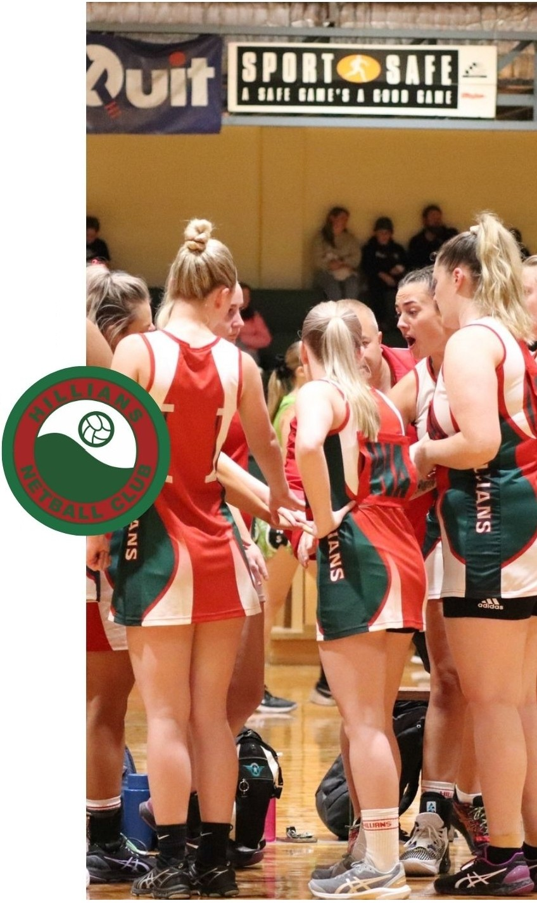

**PREMIER LEAGUE**

**17'5 & U, 18-20'5 & OPEN**

The Premier League Competition is play on a Friday Night at Ray Owen Sports Ground in Lesmurdie on the indoor courts.

Season will commence on either the last Friday in April or the first Friday in May and concludes

late August.

Finals are played in September for teams that qualify.

Hillians Netball Club Uniform is required to be purchased to be able to play in the Junior Competition - uniform order form can be found under the Uniform Tab. There will be a physical uniform sizing and purchasing day in February at Foothills Netball Courts in Maida Vale - day and time will be posted to the clubs Facebook Page

Registration for the Premier League Competition is by "Expression of Interest" only and can be emailed to hillians.[netball@gmail.com](mailto:netball@gmail.com)