

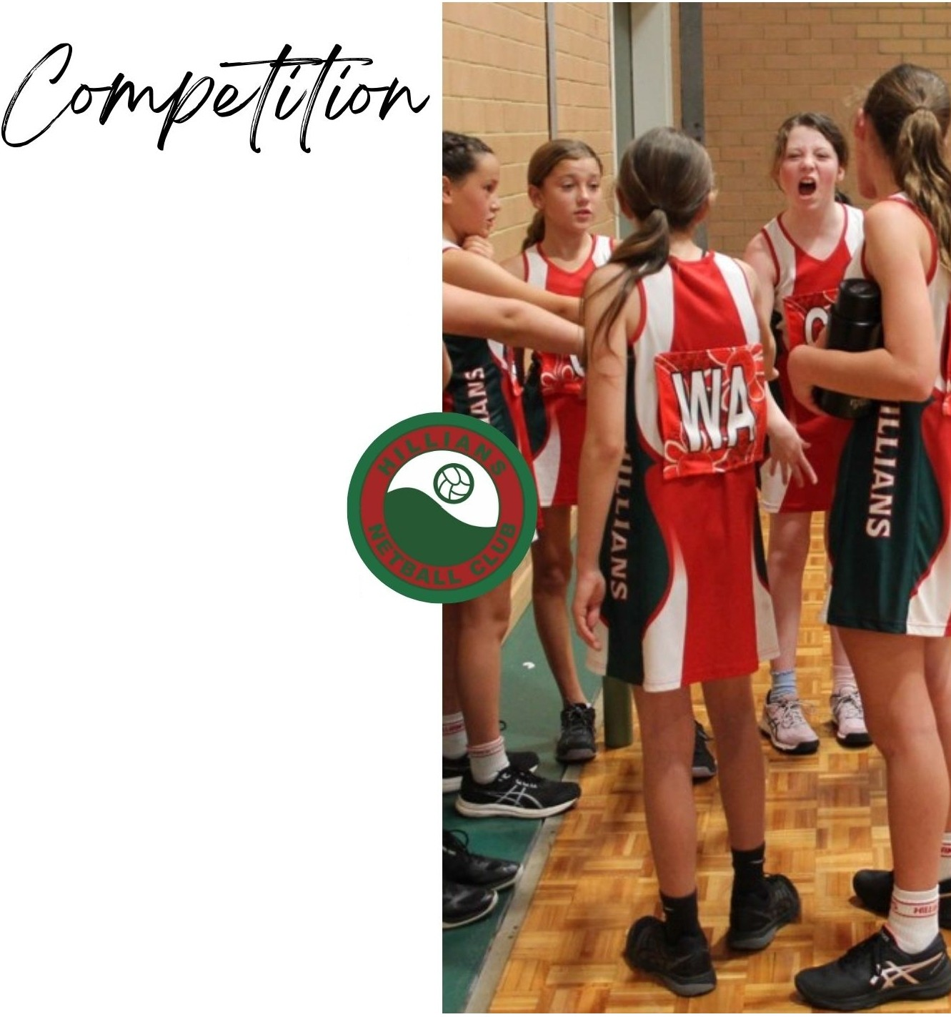

**JUNIOR**

**PLAYERS AGED 11 TO 17 YEARS**

Players in the Junior Competition are placed in teams around the same age group and then placed in appropriate age divisions by Kalamunda Districts Netball Association (KDNA) 13's & U, 15's & U and 17's & U Competitions.

Junior Teams play at Ray Owen Sport Grounds in the morning and afternoon timeslots;

(with 13's & 15's having some morning games), and season commences on either thelast Saturday

of April or the first Saturday in May and concludes

late August. Games are not played on the long weekend in June.

Junior Teams that qualify willplay in the finals series in September.

Once teams are formed players willtrain together once a week with their designated team coach - day, time to be decided by the coach.

Hillians NetballClub Uniform is required to be purchased to be able to play in the Junior Competition - uniform order form can be found under the Uniform Tab. There will be a physical uniform sizing and purchasing day in February at Foothills NetballCourts in Maida Vale day and time willbe posted to the clubs Facebook Page